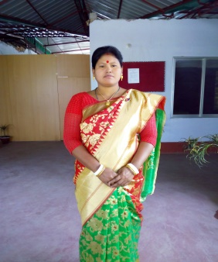

NAME: SUSHMITA SINGH
MOBILE NO--01780701452
FATHER’S NAME: SOTENDRA NATH ROY
MATHER’S NAME: SOHAGI ROY
VILL: CHAPATI ,POST: BOIRAGI HAT, P.S- :THAKURGAON SADOR,DIST: THAKURGAON
EDUCATION QUALIFICATION:
1.SSC
2.HSC
3.BSS
4.MA

EXPERIENCE:
1. LAIBRARIAN
2. COMPUTER

