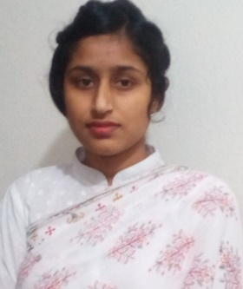

NAME: REJINA AKTER RITU
MOBILE NO +8801957164698
FATHER’S NAME: MD. JELHAQUE RAHMAN
MOTHER’S NAME: MST: JAHANARA BEGUM
VILL: GOBINDAPUR,POST: KHANSAMA,P.S- KHANSAMA, DIST: DINAJPUR
EDUCATION QAULIFICATION:
1. SSC
2.HSC
3.B.SC IN NURSING AND MIDWIFERY

NO EXOERIENCE:

