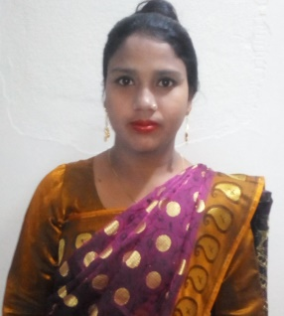

NAME: REZINA AKTER
PHONE NO: +8801764976890
FATHER’S NAME: MD. AZIZAR RAHMAN
MATHER’S NAME: MST. AZIMA BEGUM
VILL: MALLIKADAHA,POST: MALLIKADAHA,P.S- DEBIGANJ,DIST:PANCHGARCH
EDUCATION QUALIFICATION:
1.SSC
2. HSC
3. BSC IN NURSING

EXPERIENCE:
- NURSING INSTRUCTOR 1YEAR NORTH BENGAL(THAKURGAON)
2. NURSING INSTRACTOR GOLDEN LIFE1YEAR (THAKURGAON)

